***Learn How to Make a Bed as perfect***

The skill of making a bed like a professional housekeeper is taught in the following steps. If you want a nicely made bed just follow the looming easy steps to achieve a perfectly made bed.

**Step 1: Prepare the Bed - Stripping the Bed**

Before you start making the bed, remove all the existing bedding, including the sheets, pillowcases, and blankets. This step allows you to start with a clean slate and ensures that your new bedding will be fresh and neat.

Step 1: 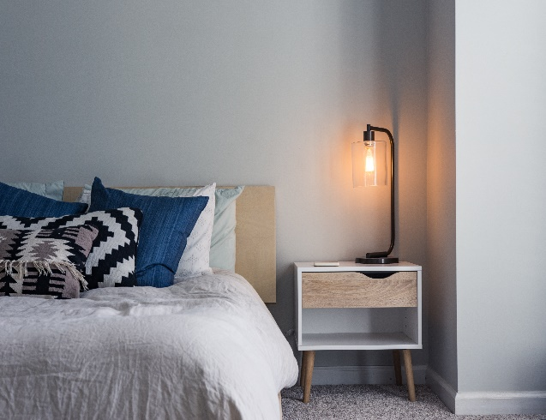

Photo by[*Christopher Jolly*](https://unsplash.com/photos/GqbU78bdJFM) on [*Unsplash*](https://unsplash.com/photos/GqbU78bdJFM)

**Step 2: Put on Fresh Fitted Sheet**

Begin by placing a fitted sheet over the mattress corners. Smooth out any wrinkles or creases, ensuring a snug fit. Make sure the elastic edges are securely tucked under the mattress to prevent the sheet from slipping off during sleep.

Step 2: 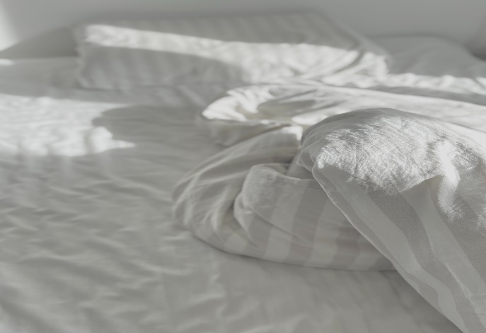

Photo by [Ryan Kwok](https://unsplash.com/photos/S1kOsHqGrw0) on [Unsplash](https://unsplash.com/photos/S1kOsHqGrw0)

**Step 3: Add Flat Sheet and Blanket**

Next, lay a flat sheet over the fitted sheet, with the top edge aligned with the head of the mattress. If you prefer an extra layer of warmth, place a lightweight blanket on top of the flat sheet. Make sure the sides and bottom edges of the sheet and blanket are even.

Step 3: 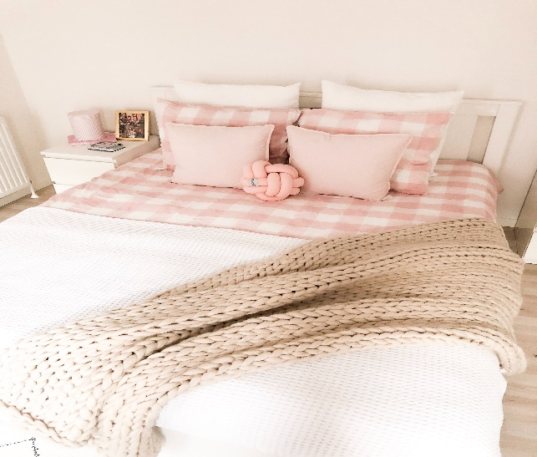

Photo by [Jelena Mirkovic](https://unsplash.com/photos/FGSycFBUkjY) on [Unsplash](https://unsplash.com/photos/FGSycFBUkjY)

**Step 4: Tucking and Folding**

To achieve a clean and crisp look, tuck the bottom edge of the flat sheet and blanket under the mattress. Pull the sheet and blanket taut to eliminate any wrinkles or bunching. Then, fold the top edge of the flat sheet over the blanket, forming a neat border that's visible when the bed is turned down

**Step 5: Arrange Pillows**

Place the pillows against the headboard, starting with the largest pillows at the back and the smaller ones in front. If you have decorative shams or pillowcases, position them at the forefront. For a luxurious touch, add a decorative cushion or two to complement the bedding.

Step 5: 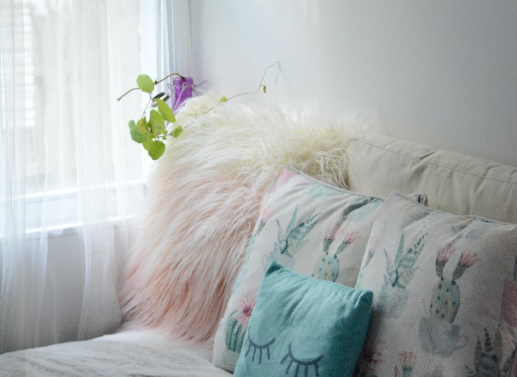

Photo by [Christina Deravedisian](https://unsplash.com/photos/nzyQEhd2GIc) on [Unsplash](https://unsplash.com/photos/nzyQEhd2GIc)

**Step 6: Drape Comforter**

Drape a bedspread or comforter over the pillows and the foot of the bed. Adjust the spread so it falls evenly on both sides and covers the bedding layers underneath. Fluff the pillows to make the bed look inviting and ready for use.

**Step 7 : Add a Fur Blanket**

To add a cozy fur blanket, you can for more softness , place a throw blanket at the foot of the bed. This can also provide extra warmth during colder nights.

Step 7 : 

Photo by [Chandan Chaurasia](https://unsplash.com/photos/3StvbB-gXpY) on [Unsplash](https://unsplash.com/photos/3StvbB-gXpY)

**Step 8: Add some decorative cushions**

To give the bedding more decorative look, add up some elegant cushions for more comfort as it can impart more comfort to the body.

Step 8 : 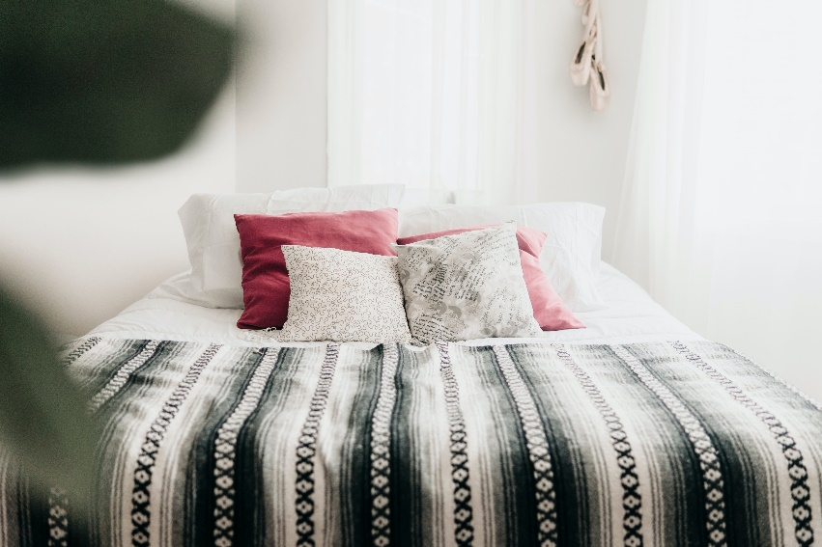

Photo by [Andrik Langfield](https://unsplash.com/photos/WBRaUr7xMDo) on [Unspash](https://unsplash.com/photos/WBRaUr7xMDo)

**Conclusion:** Congratulations! With these few procedures, you may now make a bed that is warm and aesthetically ideal for a good sleep. Enjoy your bedding with your favourite chilling activities and by scrolling the Netflix series... Good Night!!!